

**UNIVERSITY OF PETROLEUM AND ENERGY STUDIES**

**School of Computer** **Science**

**2020-21**

**GRAPHICS AND ANIMATION TOOLS LAB**

**Faculty: Dr. DURGANSH SHARMA**

**Assistant Professor**

**Department of Cybernetics.**

**School of Computer Science, UPES**

**Submitted By:**

**Name - Vartika Deep**

**SAP ID - 500062441**

**Course - B.Tech CSE (OS&OS)**

**Semester - VII**

**Batch - B3**

**Roll no. - R100217088**

**EXPERIMENT - 9**

**Design of 3D Mountain using Blender**.

**STEPS:**

1. Go to Edit - Preferences - Select A.N.T Landscape add-on.

2. Add – Mesh – Landscape.

* Set Noise Type to Multi Fractal, Random Speed to 26 ,Noise size to 0.97 and Height to 1.07.

3. Select Shade Smooth.

4. Add Subdivision Surface modifier.

5. Go to Edit mode. Select all ,press U and select Unwrap.

6. Go to shading. Select image.

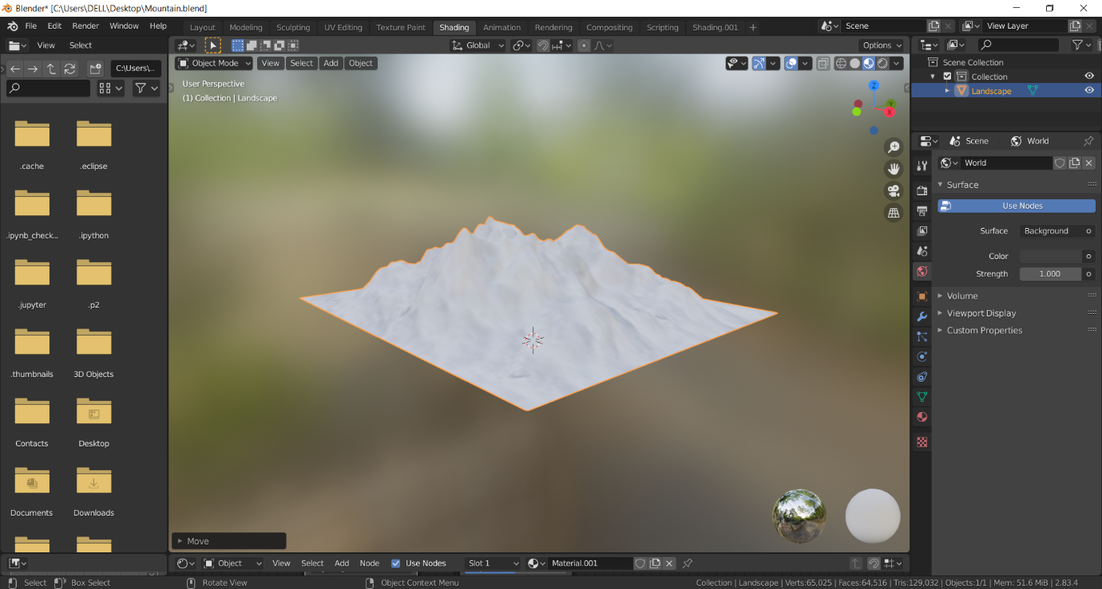

**Link :**

https://drive.google.com/file/d/16VxnCSMZBeR9zPZFqIUpdLyrW7tISKVG/view?usp=sharing